**Problem 8:Write a program to display a “?” , read two capital letters, and display them on the next line in alphabetical order.**

.model small

.stack 100h

.data

msg1 db "Tanvir Ahmmed Sifat IT20026$"

msg2 db 10,13,"$"

.code

main proc

mov ax,@data

mov ds,ax

mov ah,9

lea dx,msg1

int 21h

lea dx,msg2

int 21h

mov ah,2

mov dl,'?'

int 21h

mov ah,1

int 21h

mov bl,al

int 21h

mov cl,al

mov ah,2

mov dl,10

int 21h

mov dl,13

int 21h

cmp bl,cl

jl nxt

mov dl,cl

int 21h

mov dl,bl

int 21h

jmp dos_exit

nxt:

mov dl,bl

int 21h

mov dl,cl

int 21h

dos_exit:

mov ah,4ch

int 21h

main endp

end main

**Output:**

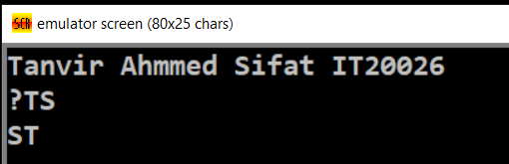

**Problem 9: Write a program to display the extended ASCII characters. Display 10 characters per line, separated by blanks. Stop after the extended character have been displayed once.**

**Solution:**

.model small

.stack 100h

.data

msg1 db "Tanvir Ahmmed Sifat IT20026$"

msg2 db 10,13,"$"

.code

main proc

mov ax,@data

mov ds,ax

mov ah,9

lea dx,msg1

int 21h

lea dx,msg2

int 21h

mov cx,127

mov bl,0

show:

mov ah,2

inc cx

cmp cx,255

jg dos_exit

mov dx,cx

int 21h

mov dx,32

int 21h

jmp go

go:

inc bl

cmp bl,10

je print

jmp show

print:

mov ah,2

mov dl,10

int 21h

mov dl,13

int 21h

mov bl,0

jmp show

dos_exit:

mov ah,4ch

int 21h

main endp

end main

**Output:**

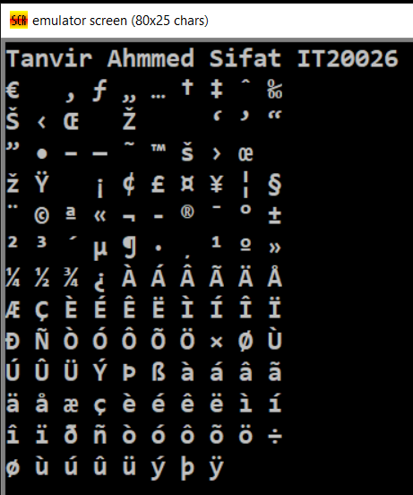

**Problem- 10:** Write a program that will prompt the user to enter a hex digit character (“0” ….”9” or “A” ..”F”) display it on the next line in decimal, and ask the user if he or she wants to do it again. If the user types anything else, the program terminates. If the user enters an illegal character, prompt the user to try again.

**Solution:**

.model small

.stack 100h

.data

a db 'Tanvir Ahmmed Sifat IT20026$'

b db 10,13,'$'

mg1 db 10,13,'Enter a hex digit $'

mg2 db 10,13,'In decimal is it $'

mg3 db 10,13,'Do you want to do it again $'

mg4 db 10,13,'Illegal character. enter 0-9 or A-F $'

.code

main proc

mov ax,@data

mov ds,ax

mov ah,9

lea dx,a

int 21h

lea dx,b

int 21h

again:

mov ah,9

lea dx,mg1

int 21h

mov ah,1

int 21h

mov bl,al

jmp do

do:

cmp bl,'9'

jg hex

je num

jl num

hex:

cmp bl,'F'

jg illegal

mov ah,9

lea dx,mg2

int 21h

mov dl,49

mov ah,2

int 21h

mov ah,2

sub bl,17

mov dl,bl

int 21h

jmp inp

inp:

mov ah,9

lea dx,mg3

int 21h

mov ah,1

int 21h

mov cl,al

cmp cl,'Y'

je again

cmp cl,'y'

je again

jmp exit

num:

cmp bl,'0

jl illegal

lea dx,mg2

int 21h

mov ah,9

int 21h

mov dl,bl

mov ah,2

int 21h

jmp inp

illegal:

lea dx,mg4

mov ah,9

int 21h

mov ah,1

int 21h

mov bl,al

jmp do

exit:

mov ah,4ch

int 21h

main endp

end main

**Output:**

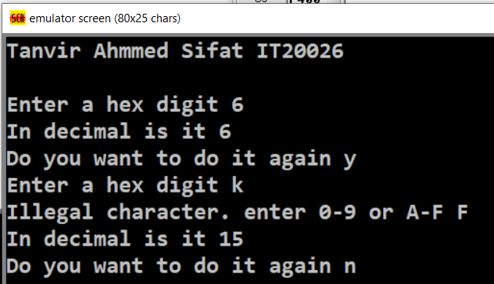

**Exercise 11*:*** Do programming exercise 10, except that if the user fails to enter a hex-digit character in three tries, display a message and terminate the program.

**Solution:**

.model small

.stack 100h

.data

a db 'Tanvir Ahmmed Sifat IT20026$'

b db 10,13,'$'

mga db 10,13,'ENTER A HEX DIGIT:$'

mgb db 10,13,'IN DECIMAL IS IT:$'

mgc db 10,13,'DO YOU WANT TO DO IT AGAIN?$'

mgd db 10,13,'ILLEGAL CHARACTER- ENTER 0-9 OR A-F:$'

mge db 10,13,'Too Many Try$'

.code

main proc

mov ax,@data

mov ds,ax

mov ah,9

lea dx,a

int 21h

lea dx,b

int 21h

again:

mov cx,0

lea dx,mga

mov ah,9

int 21h

mov ah,1

int 21h

mov bl,al

jmp go

go:

cmp bl,'9'

jg hex

jl num

je num

hex:

cmp bl,'F'

jg illegal

lea dx,mgb

mov ah,9

int 21h

mov dl,49d

mov ah,2

int 21h

sub bl,17d

mov dl,bl

mov ah,2

int 21h

jmp inp

inp:

lea dx,mgc

mov ah,9

int 21h

mov ah,1

int 21h

mov cl,al

cmp cl,'y'

je again

cmp cl,'Y'

je again

jmp exit

num:

cmp bl,'0'

jl illegal

lea dx,mgb

mov ah,9

int 21h

mov dl,bl

mov ah,2

int 21h

jmp inp

illegal:

inc cx

cmp cx,3

je i2

lea dx,mgd

mov ah,9

int 21h

mov ah,1

int 21h

mov bl,al

jmp go

i2:

lea dx,mge

mov ah,9

int 21h

jmp exit

exit:

mov ah,4ch

int 21h

main endp

end main

**Output:**

